CHILD HEALTH MONITORING SYSTEM THROUGH SALIVA

NAME: SHAIK BASHE

COLLEGE: LAKIREDDY BALI REDDY COLLEGE OF ENGINEERING ,NTR DISTRICT, AP

HACKTHON: BIO-E-TECH

--------- INTRODUCTION---------

CHILDREN’S HEALTH IS VERY IMPORTANT, ESPECIALLY WHEN THEY ARE YOUNG AND CANNOT EXPLAIN HOW THEY FEEL. MANY TIMES, HEALTH PROBLEMS LIKE INFECTIONS OR POOR DIET ARE NOT NOTICED EARLY. TO SOLVE THIS, WE DESIGNED A SYSTEM THAT CHECKS A CHILD’S HEALTH USING SALIVA.

SALIVA (THE LIQUID IN THE MOUTH) HAS A PH VALUE THAT CAN TELL IF THE BODY IS HEALTHY OR NOT. IF THE SALIVA IS TOO ACIDIC OR TOO BASIC, IT MAY INDICATE PROBLEMS LIKE DEHYDRATION, INFECTIONS, OR POOR NUTRITION.

IN THIS PROJECT, WE USE A PH SENSOR AND AN ARDUINO BOARD TO MEASURE THE SALIVA’S PH. BASED ON THE READING, DIFFERENT LED LIGHTS WILL GLOW TO SHOW IF THE HEALTH CONDITION IS GOOD, MODERATE, OR BAD. WE ALSO USE PYTHON TO CREATE LIVE GRAPHS AND SEND WEEKLY PDF REPORTS TO PARENTS

THIS SYSTEM IS SIMPLE, SAFE, AND PAINLESS FOR CHILDREN. IT HELPS PARENTS TAKE EARLY ACTION BEFORE THE HEALTH ISSUE GETS WORSE.

-----PROBLEM STATEMENTS AND ITS SOLUTIONS----

Q1: WHY IS SALIVA PH IMPORTANT FOR HEALTH?

SALIVA PH SHOWS THE BALANCE BETWEEN ACIDS AND BASES IN THE BODY.

IT HELPS IN IDENTIFYING EARLY SIGNS OF HEALTH PROBLEMS.

Q2: WHAT ARE THE CURRENT PROBLEMS IN CHILD HEALTH MONITORING?

CHILDREN OFTEN CANNOT DESCRIBE THEIR SYMPTOMS CLEARLY.

REGULAR MONITORING AT HOME IS MISSING IN MOST CASES.

Q3: WHAT DO WE TEST BASED ON SALIVA?

WE TEST THE PH VALUE OF SALIVA TO CHECK IF IT IS TOO ACIDIC OR BASIC.

IT HELPS IN CLASSIFYING HEALTH AS GOOD, MODERATE, OR RISKY

Q4: WHAT ARE THE POSSIBLE HEALTH ISSUES DETECTED THROUGH SALIVA PH?

ABNORMAL PH LEVELS CAN INDICATE DEHYDRATION, TOOTH DECAY, OR INFECTIONS.

THEY MAY ALSO POINT TO POOR NUTRITION OR IMMUNE IMBALANCE

-----COMPONENTS USED IN THE PROJECT------

1. Arduino UNO – Microcontroller board to control the system

2. pH Sensor (or Potentiometer for simulation) – To detect saliva pH level

3. Red, Blue, and Green LEDs – To indicate acidic, neutral, and alkaline pH level

4. Breadboard – For easy and temporary circuit connections

5. Jumper Wires – To connect components on the breadboard

6. USB Cable – To upload code and power the Arduino

7. Computer/Laptop – For coding (Arduino IDE + Python)

8. Resistors (220Ω) – To limit current for the LEDS

--------------CIRCUIT DIAGRAM--------------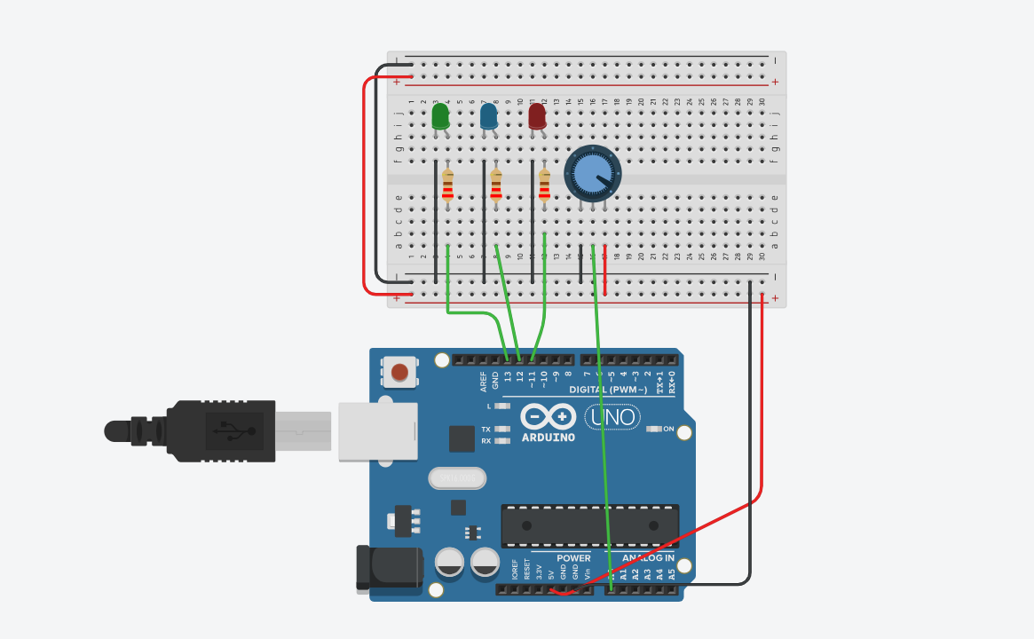

-------------------------------OUTPUT-----------------------------------

IN THE ORIGINAL PROJECT, IMAGES AND HEALTH MESSAGES ARE SHOWN BASED ON SALIVA PH.

BUT IN TINKERCAD, PH SENSOR AND DISPLAY ARE UNAVAILABLE.

WE USED A POTENTIOMETER TO SIMULATE PH VALUES AND LEDS FOR INDICATION.

RED, GREEN, AND BLUE LIGHTS SHOW HEALTH CONDITIONS INSTEAD OF IMAGES.

(DIFFERENT SYMOBLIS LIKE 🔥 ✅ ) PRESENT IN MY CIRCUIT WE use ONLY POTENTIOMETER TO INDICATE THE SITUATION THROUGH ONLY LIGHTS)

OUTPUT-1

RED LIGHT INDICATES PH IS VERY ACIDIC(BELOW 5)

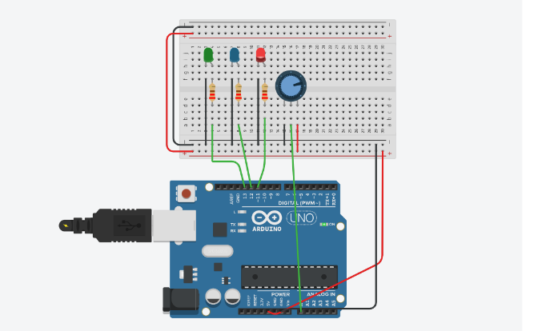

OUTPUT-2

GREEN LIGHT PH IS NEUTRAL OR HEALTHY (6.5 TO 7.5)

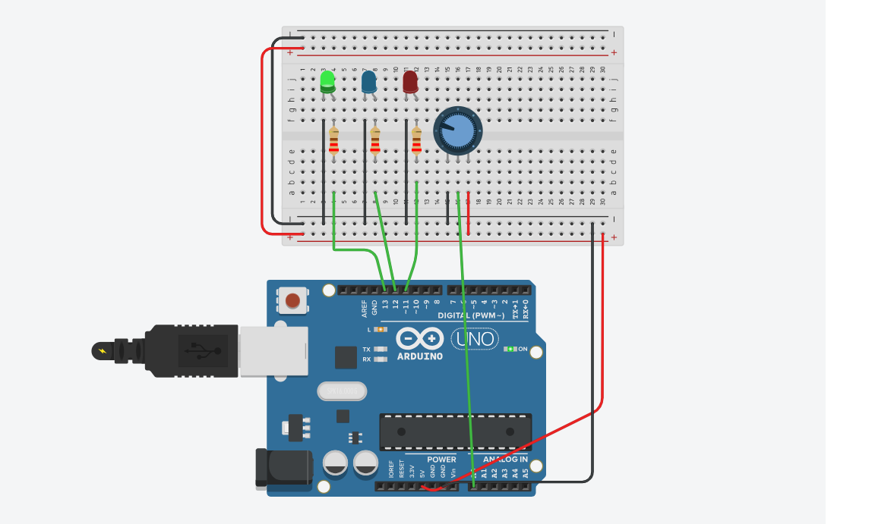

OUTPUT-3

BLUE LIGHT IT GLOWS PH IS TOO ALKALINE(ABOVE 8.0)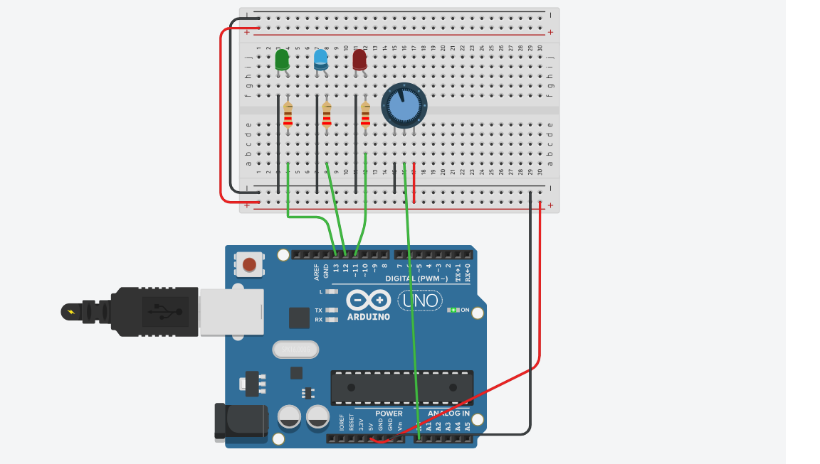

-------FEATURES OF THE SYSTEM-----

1. Saliva-Based Health Detection

Detects saliva pH levels to assess oral and general health of children.

2. LED Visual Indicators

Uses Red, Green, and Blue LEDs to show health conditions clearly and instantly:

Red: Acidic (unhealthy)

Green: Neutral (healthy)

Blue: Alkaline (potential concern)

3. Sensor Simulation with Potentiometer

In Tinkercad, a potentiometer is used to simulate changing pH levels due to unavailability of pH sensor.

4. Arduino-Controlled Logic

Arduino Uno processes pH input and controls LED output for real-time feedback.

5. Child-Friendly Output Labels (WHEN PROPER PH SENSOR USED THEN IT WILL SHOW .

PRESENT WE use ONLY POTENTIOMETER TO INDICATE THE SITUATION THROUGH ONLY LIGHTS)

Fun labels like “Dragon Fire 🔥” or “Health Hero ✅” to make it understandable and engaging for kids.

6. Simple and Low-Cost Setup

Uses easily available components (LEDs, Arduino, Potentiometer) making it affordable for school/early health setups. https://youtu.be/8TctnQwHIaQ?feature=shared

-----GITHUB REPOSITORY LINK------

<https://github.com/shaikbashe1/child-health-monitoring-system-through-saliva>

-------YOU TUBE VIDEO LINK---------

<https://youtu.be/8TctnQwHIaQ?feature=shared>

----IMPORTANT NOTE ----

In your actual project idea, the output would show different images and health advice based on saliva pH levels (like cartoons, health tips, etc.).

But in the Tinkercad simulation, since we don’t have a real pH sensor or display screen, the output is only shown through LED light indicators:

🔴 Red LED = Unhealthy pH (Too acidic or too basic)

🟢 Green LED = Normal/Healthy pH

🔵 Blue LED = Slightly off but not critical

----------------THANK YOU--------------